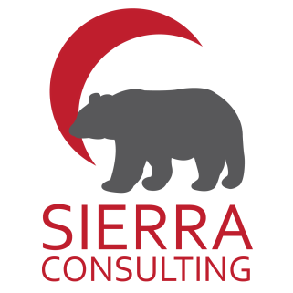

*Wanting to get up to speed on Ec. Dev. initiatives in your Community?*

*Have economic develop suggestions for GIFN?*

*Your Input is Needed*

## Great Prizes to be won!

# Economic Development

# Engagement Session

### Please Contact:

### **Marlene Stiles**

Ec. Dev. Officer

[marlene.stiles@georginaisland.com](mailto:marlene.stiles@georginaisland.com)

705-437-1337

The GIFN Economic Development Department in partnership with Sierra Consulting is hosting a community engagement session to gather input needed to update the Community’s Economic Strategic Plan.

Together we will chat about:

* GIFN Ec. Dev. Highlights
* Past Developers and Visionaries
* Communal Economic Development Functions
* Need for Communal Ec. Dev. Corporation
* Supports for Entrepreneurs
* Use of Communal Resources
* Future Opportunities
* Business Readiness

***Meeting to be held at Community Centre***

***11:00 am***

***March 11th, 2020***

Please join us on Wednesday

March 11th, 2020 – Community Centre